July 21, 2026

TO: District 10 Local Union Presidents, Recording Secretaries, and Unit Presidents

Dear Union Brothers and Sisters:

The 2026 Local Union Presidents/Officers Meetings have been scheduled according to the following information

- MONDAY, NOVEMBER 9  Meeting begins at 9:00 AM  USW International Headquarters  60 Boulevard of the Allies – 4th Floor  Pittsburgh, PA 15222  RSVP by October 23 | - THURSDAY, NOVEMBER 12  Meeting begins at 9:00 AM  Local 2599 Union Hall  53 East Lehigh Street  Bethlehem, PA 18018  RSVP by October 27

Presidents, Unit Presidents, and Staff Representatives, along with other officers, are encouraged to attend and participate in these informative meetings. Each Local Union will be responsible for any lost time, travel, and expenses. Lunch will be provided; therefore, we request that you please return the enclosed registration form by fax (412) 829-2861, email poconnell@usw.org, or mail USW District 10, Attention: LU Officers Meeting, 1001 Ardmore Blvd., Suite 200, Pittsburgh, PA 15221 to confirm the number of attendees from your local.

In solidarity,
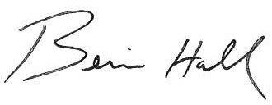

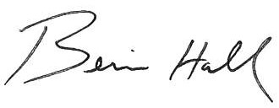
Bernie Hall
District 10 Director

BH/pdo
Enclosure

cc: Todd Clary, Assistant to the Director
Staff Representatives

