May 27, 2026

TO: Local Union Presidents, Recording Secretaries and Unit Presidents

Dear Union Brothers and Sisters:

District 10 will offer the Women of Steel Leadership Development Course - Level I for Local Union members at Linden Hall in Dawson, PA from Sunday, September 27, 2026 to Thursday, October 1, 2026. Registration is Sunday at 3:00 pm followed by dinner at 5:00 pm and there will be a Welcome Session at 6:00 pm. Monday through Wednesday classes will be held from 8:00 am to 5:00 pm and on Thursday from 8:00 am to 1:00 pm.

This course has been developed to give women the basics in unionism.

Registration and Hotel Information

The registration fee for the seminar is $480 per person and includes room (double occupancy for Local Union members only), classroom materials, and meals. Please indicate on the registration form if there are members who prefer to share a room. All others will be assigned a roommate after registrations are received. If you wish to request or require a single room, the cost of the registration fee is $880 and subject to availability. The District 10 office will make the room reservations. For anyone not staying overnight at Linden Hall, the registration fee for the seminar is $200 per person for classroom materials and meals. This is subject to change.

Registration forms should be received at the District 10 office by Friday, August 21, 2026. After this date, registrations will only be accepted if rooms are still available. Each Local Union will be responsible for any lost time, travel, and expenses. I encourage all Local Unions to participate in this course.

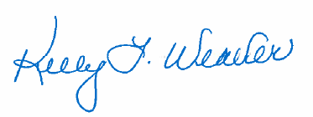
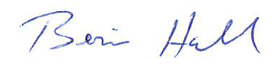
In solidarity,

Bernie Hall, Director Kelly Weaver
USW District 10 WOS Coordinator

BH/KW/tlw

Enclosure

cc: Staff Representatives and Administrative Assistants

