.

May 15, 2026

TO: District 10 Presidents, Recording Secretaries, and Unit Presidents

Dear Brothers and Sisters:

District 10 is pleased to announce a Collective Bargaining Seminar for Local Union members, which will be held at the USW International Headquarters on the Fourth (4th) Floor, located at 60 Boulevard of the Allies, Pittsburgh, PA 15222.

The course is scheduled to take place from Monday, September 14, 2026 to Thursday, September 17, 2026. Classes will run from 9:00 AM to 5:00 PM each day, Monday through Thursday and lunch will be provided to all participants.

The registration fee for the course is $100 per person. However, Local Unions will be responsible for any lost time, travel expenses, and overnight stays if needed.

For your convenience, we have reserved a block of rooms at the Wyndham Grand Downtown Pittsburgh, 600 Commonwealth Place, Pittsburgh, PA 15222, for the nights of Sunday, September 13, 2026 through Wednesday, September 16, 2026. Check-out is on Thursday, September 17, 2026 by 11:00 AM. The hotel is conveniently located just one block away from the USW building.

You can book online at https://book.passkey.com/go/uswcollectivebargaining. The group rate is $124/night plus taxes & fees. The deadline for hotel reservations is
August 28, 2026.

Registration forms should be received at the District 10 office by Tuesday, September 1, 2026. To register, please make checks payable to the “District 10 Education Fund” and send them, along with the completed registration form, to USW District 10, Attn: Collective Bargaining, 1001 Ardmore Blvd., Suite 200, Pittsburgh, PA 15221.

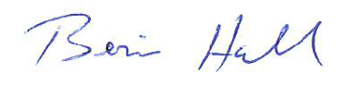
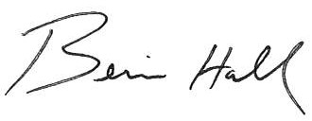
In solidarity,

Bernie Hall
District 10 Director

BH/tlw

Enclosure: Registration Form

cc: District 10 Staff Representatives and Administrative Assistants

